NURSERY
WRITING PATTERN EX BOOK 1 COMPLETE PG NO. 9&10.
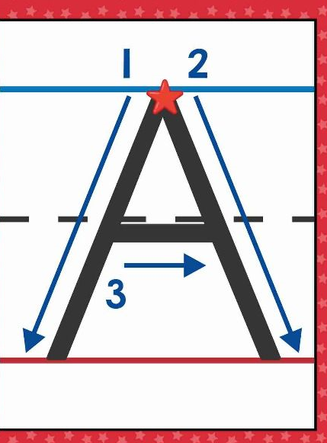 STROKE FOR CAPITAL A.
COMPLETE PG.NO – 2 FROM EX BOOK 2.
PRACTICE NUMBER 1(ONE) - GO- OVER.

FILE READING
ENGLISH - “A “ TO “O”.
HINDI - 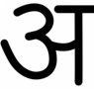 TO 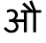
MATHS – 1 TO 25
LEARN IT-
WHAT IS YOUR NAME? WHERE DO YOU LIVE?
MY NAME IS................... I LVE AT HAZARIBAGH.
HOW OLD ATRE YOU?
I AM 3 YEARS OLD.

